**Use Case 1:- (Create Queries)**

1. Creating database named Book_Store  
   CREATE DATABASE BOOK_STORE;

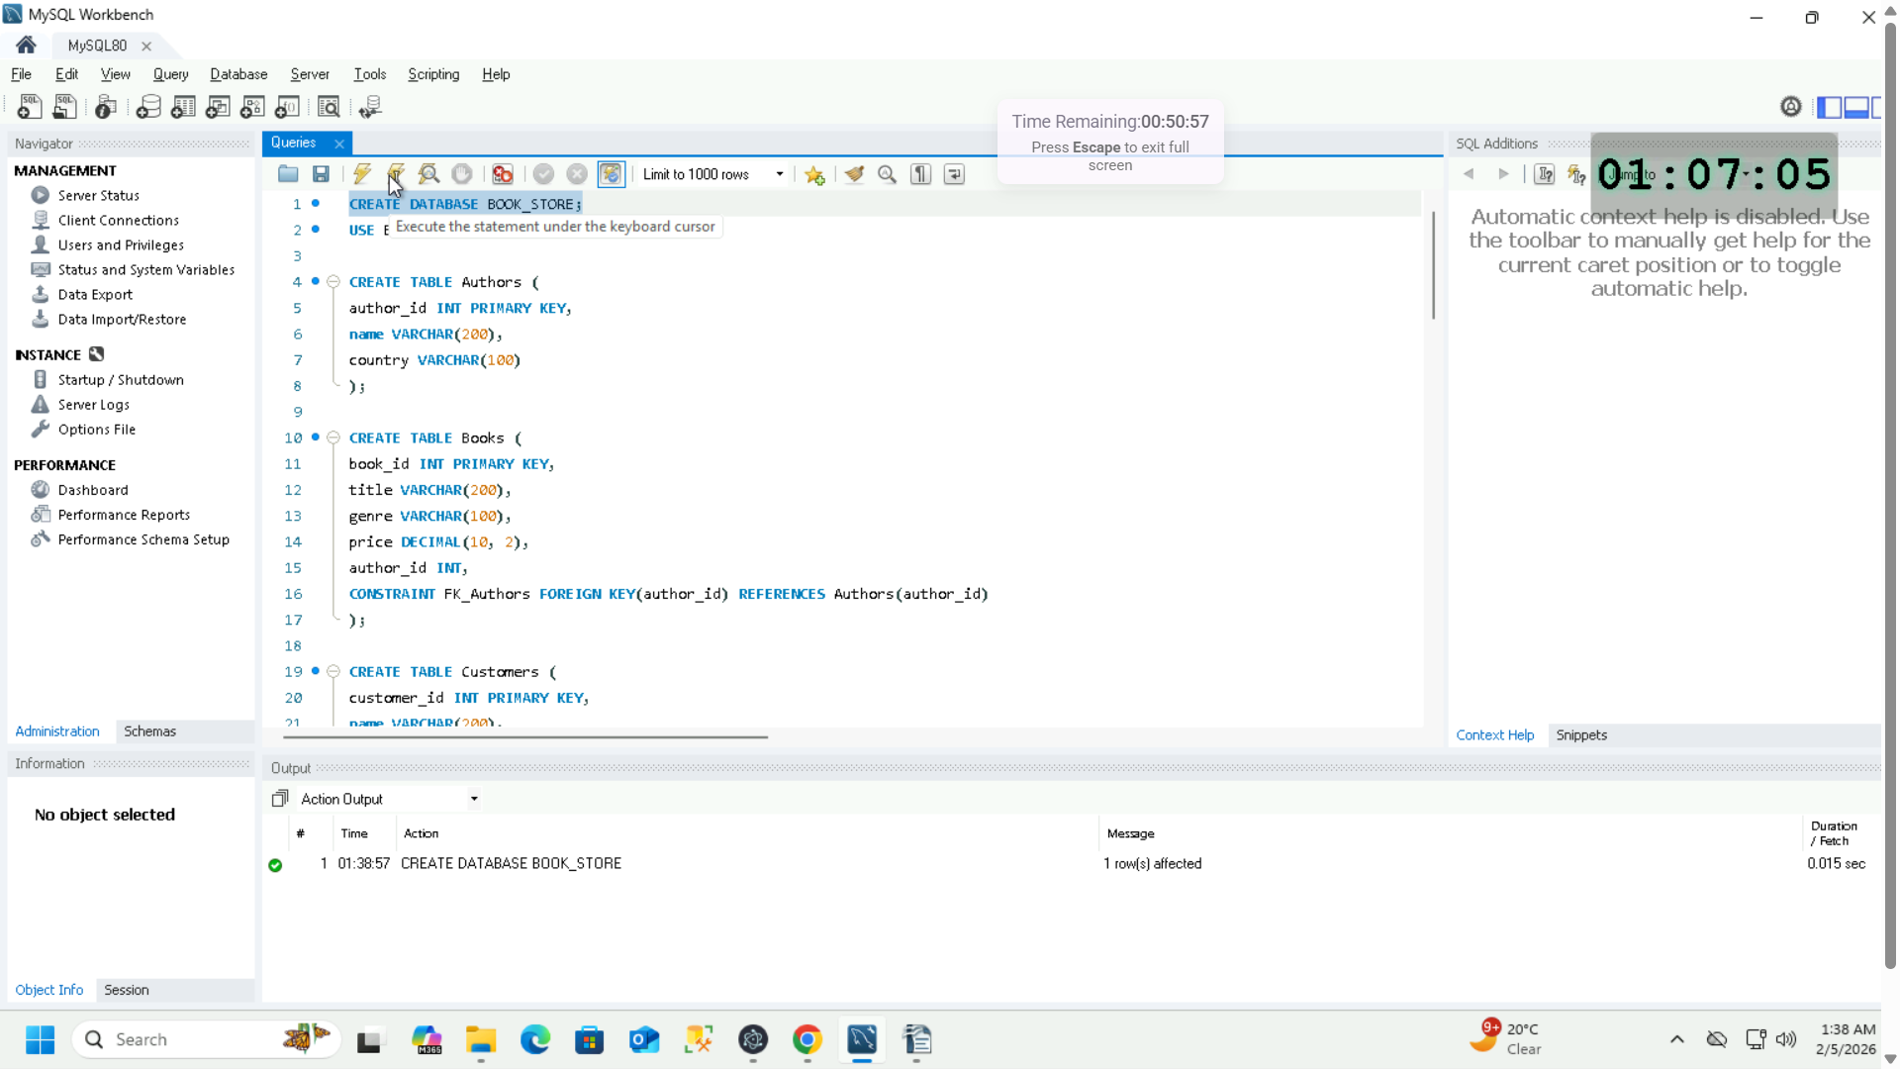

1. Now, use this created database  
   USE BOOK_STORE;

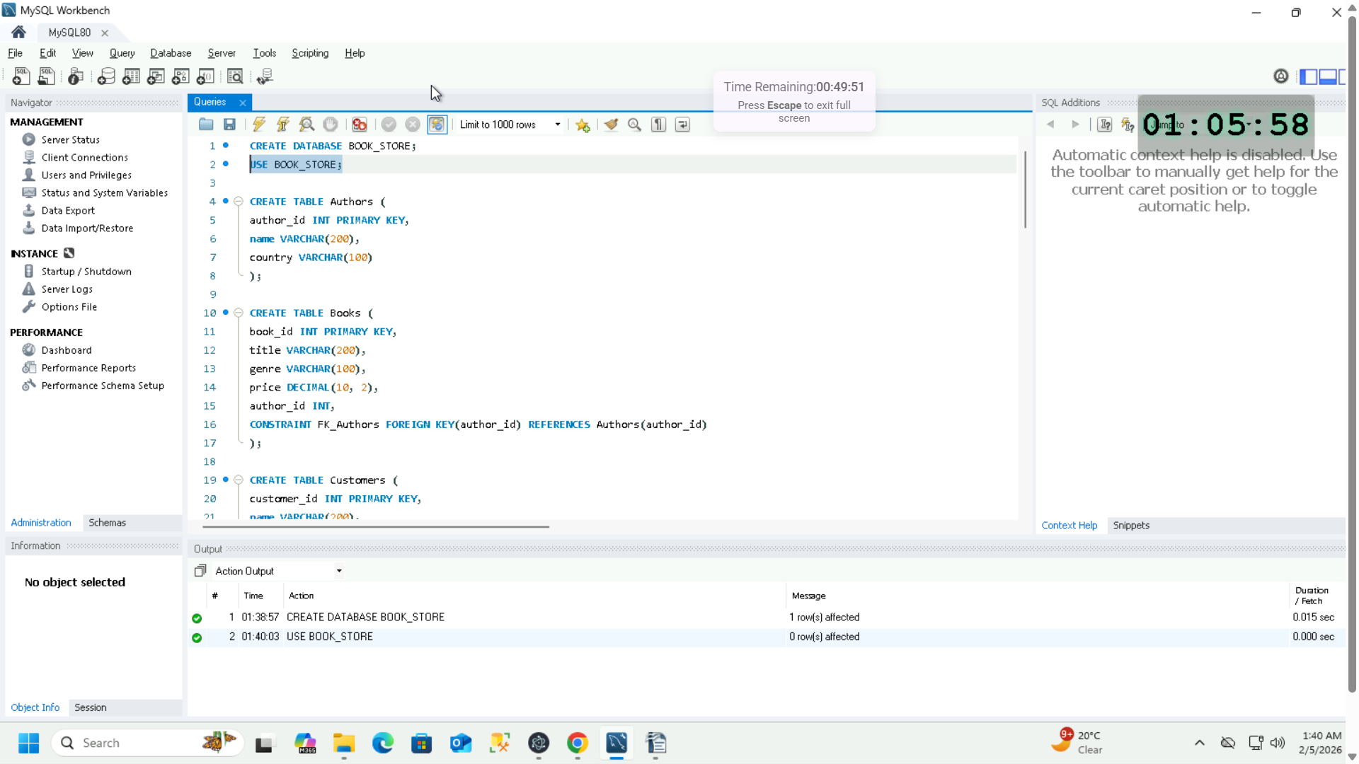

1. Create a table names Authors having primary key as author_id  
   CREATE TABLE Authors (  
   author_id INT PRIMARY KEY,  
   name VARCHAR(200),  
   country VARCHAR(100)  
   );

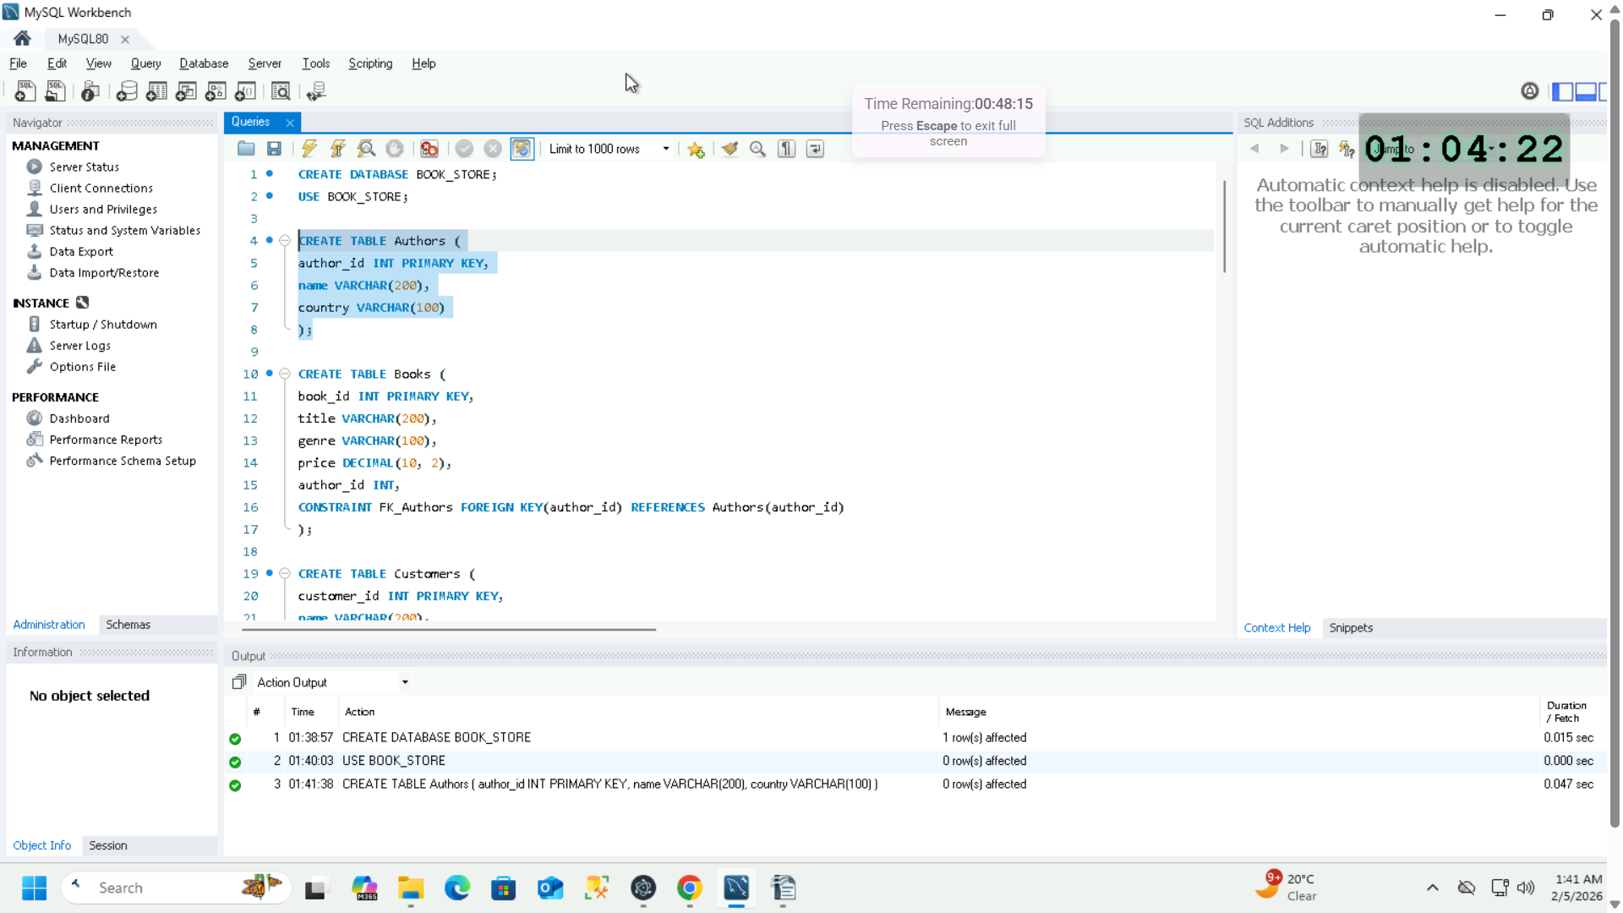

1. Create a table named Books having primary key as book_id and foreign key as author_id from the Authors table  
     
   CREATE TABLE Books (  
   book_id INT PRIMARY KEY,  
   title VARCHAR(200),  
   genre VARCHAR(100),  
   price DECIMAL(10,2),  
   author_id INT,  
   CONSTRAINT FK_Authors FOREIGN KEY(author_id) REFERENCES Authors(author_ID)  
   );

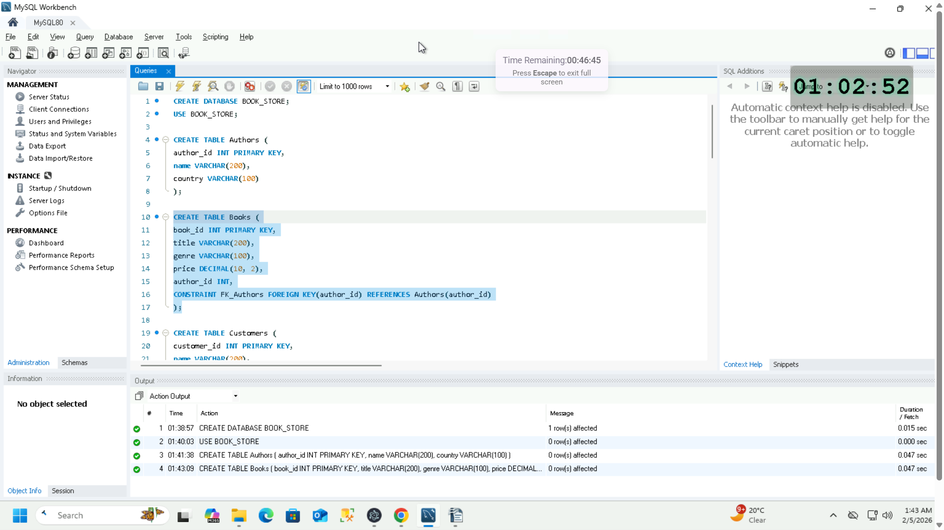

1. Create a table named Customers having customer_id as Primary key  
   CREATE TABLE Customers (  
   customer_id INT PRIMARY KEY,  
   name VARCHAR(200),  
   email VARCHAR(200)  
   );

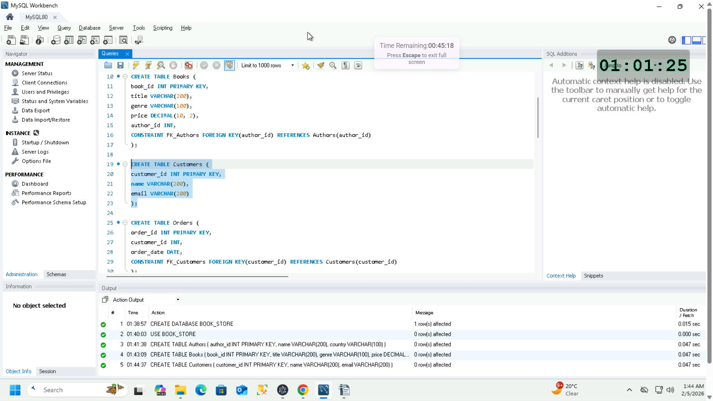

1. Create a table named Orders having order_id as Primary key and customer_id as Foreign Key from the Customers table  
   CREATE TABLE Orders (  
   order_id INT PRIMARY KEY,  
   customer_id INT,  
   order_date DATE,   
   CONSTRAINT FK_Customers FOREIGN KEY(customer_id) REFERENCES Customers(customer_id)  
   );

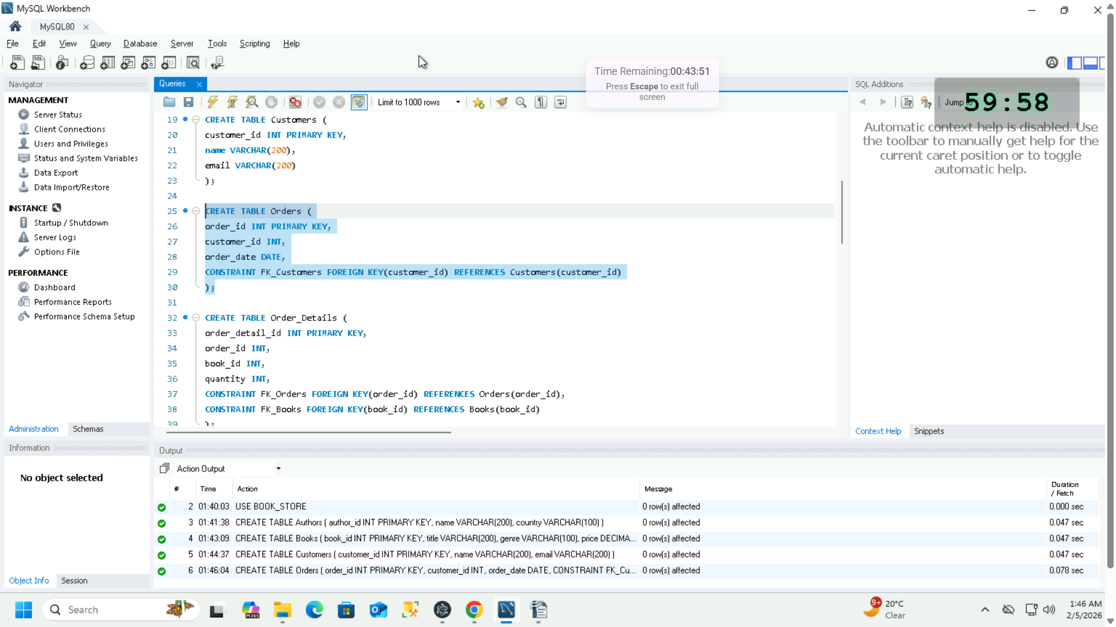

1. Create a table named Order_Details having order_detail_id as Primary key and order_id as Foreign Key from Orders table and book_id as Foreign Key from Books table  
   CREATE TABLE Order_Details (

order_detail_id INT PRIMARY KEY,

order_id INT,

book_id INT

Quantity INT,

CONSTRAINT FK_Orders FOREIGN KEY(order_id) REFERENCES Orders(order_id),

CONSTRAINT FK_Books FOREIGN KEY(book_id) REFERENCES Books(book_id)

);

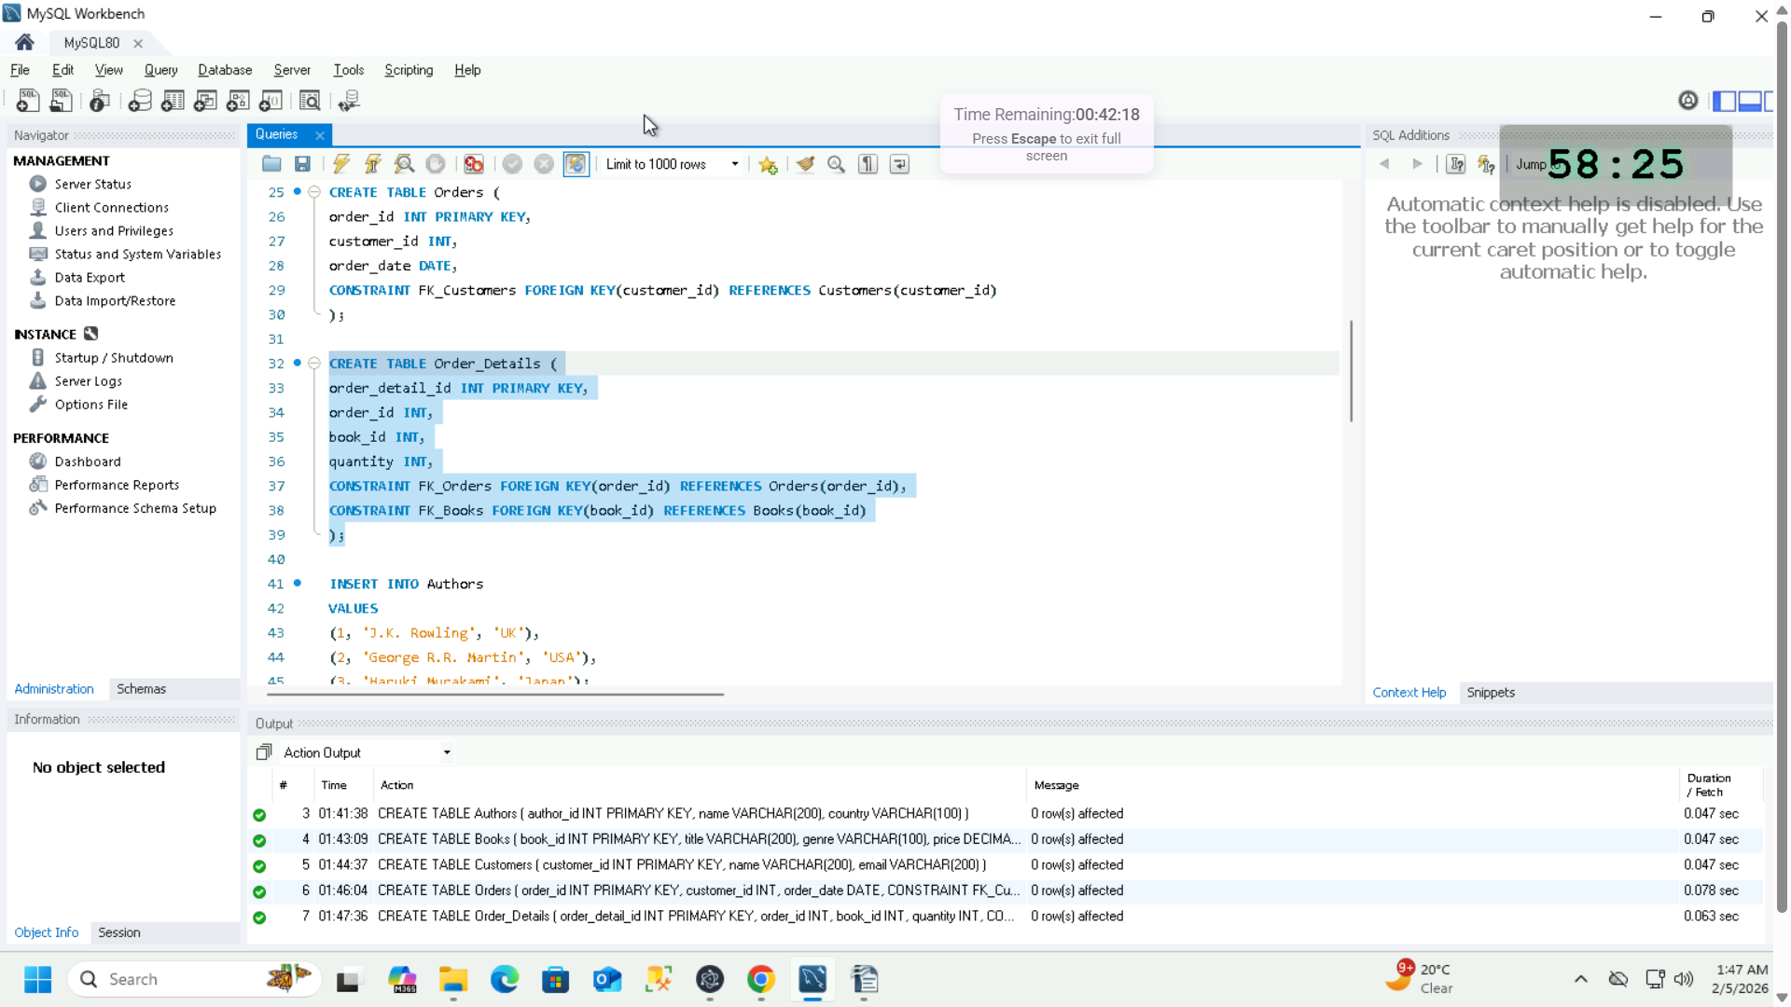

**Use Case 2:- (Insert Queries)**

1. Insert Values into Authors table  
   INSERT INTO Authors

VALUES

(1, ‘J.K. Rowling’, ‘UK’),

(2, ‘George R.R. Martin’, ‘USA’),

(3, ‘Haruki Murakami’, ‘Japan’);

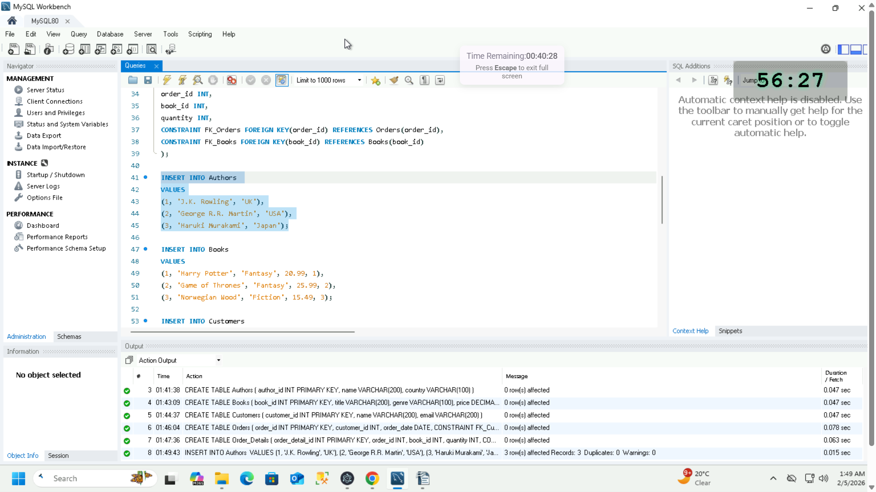

1. Insert Values into Books table  
   INSERT INTO Books

VALUES

(1, ‘Harry Potter’, ‘Fantasy’, 20.99, 1),

(2, ‘Game of Thrones’, ‘Fantasy’, 25.99, 2),

(3, ‘Norwegian Wood’, ‘Fiction’, 15.49, 3);

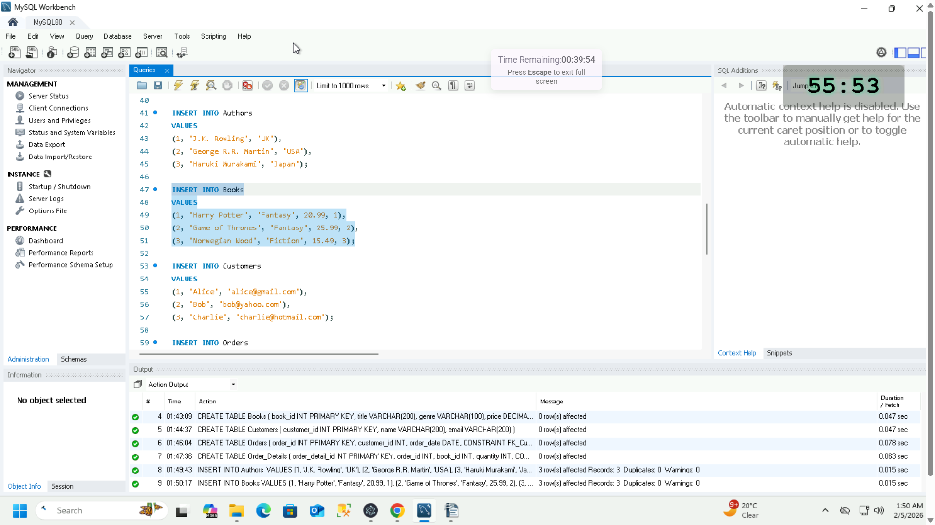

1. Insert Values into Customers table  
   INSERT INTO Customers

VALUES

(1, ‘Alice’, ‘alice@gmail.com’),

(2, ‘Bob’, ‘bob@yahoo.com’),

(3, ‘Charlie’, ‘charlie@hotmail.com’);

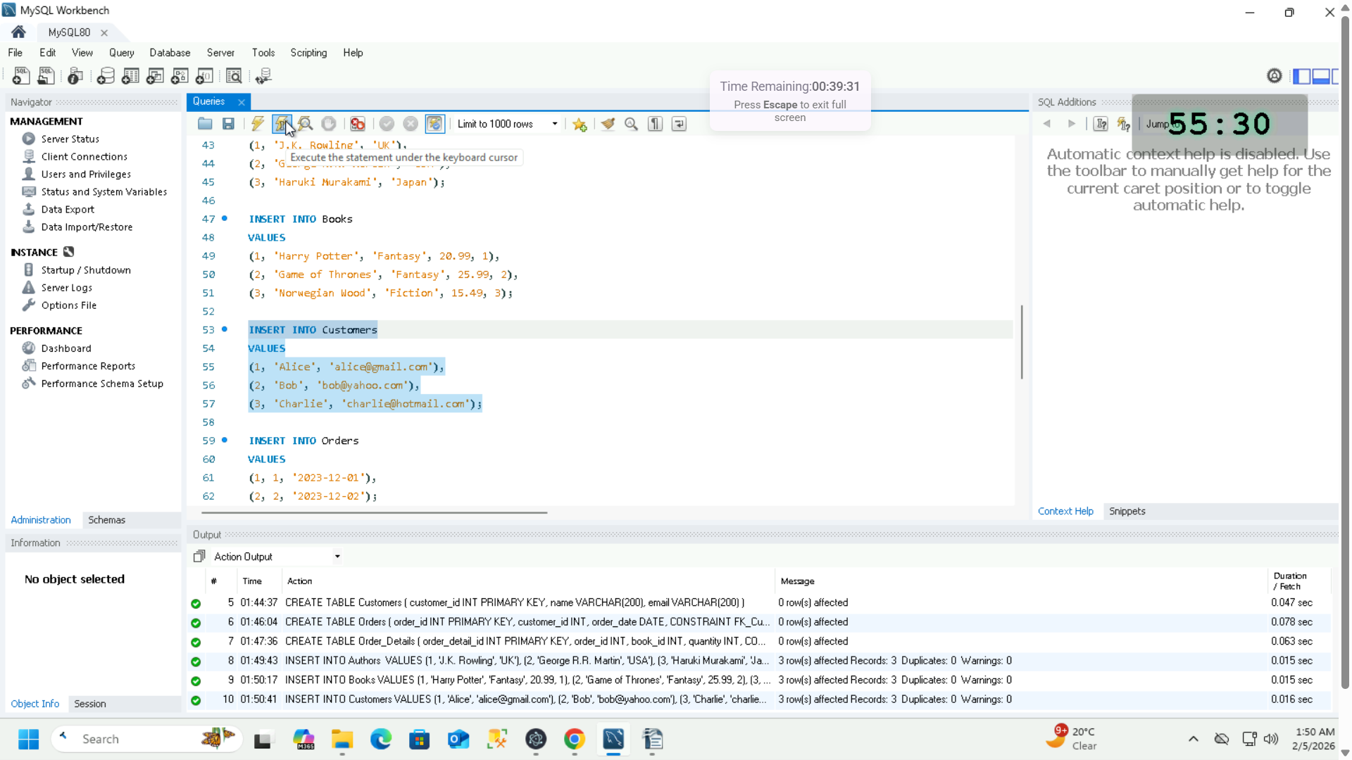

1. Insert Values into Orders table  
   INSERT INTO Orders

VALUES

(1, 1, ‘2023-12-01’),

(2, 2, ‘2023-12-02’);

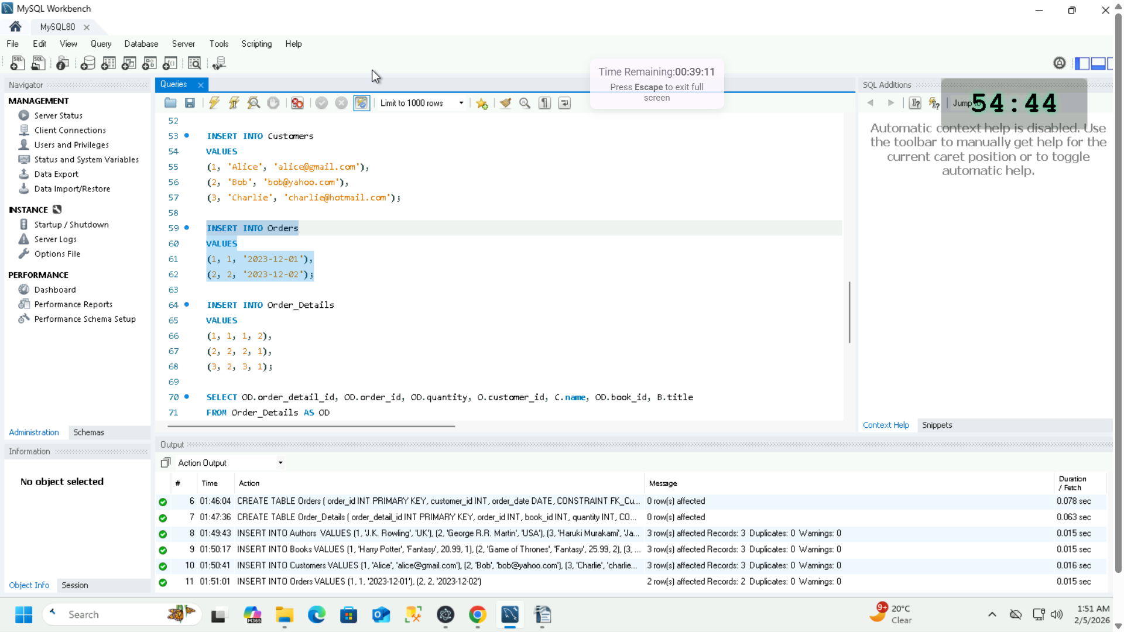

1. Insert Values into Order_Details table  
   INSERT INTO Order_Details

VALUES

(1, 1, 1, 2),

(2, 2, 2, 1),

(3, 2, 3, 1);

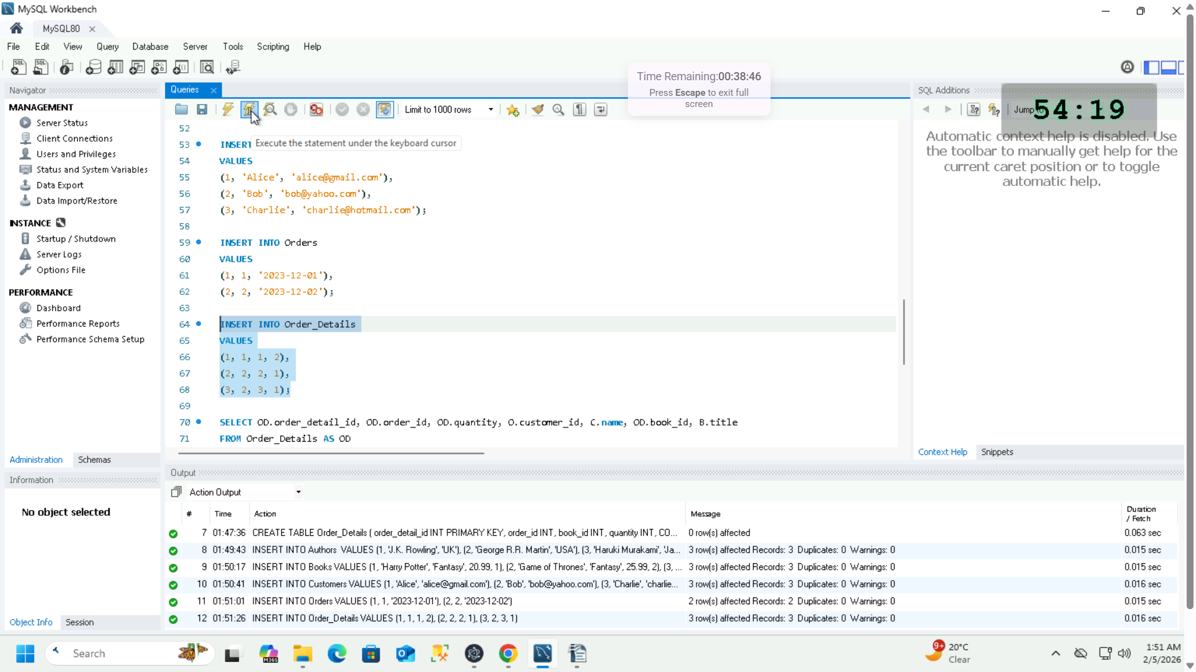

**Use Case 3:- (Joins)**

1. Joining Order_details, Orders, Books & Customers tables using their Foreign Keys to display all orders along with the names of customers and the title of books they ordered  
   SELECT OD.order_detail_id, OD.order_id, OD.quantity, O.customer_id, C.name, OD.book_id, B.title

FROM Order_Details AS OD

JOIN Orders AS O ON OD.order_id = O.order_id

JOIN Customers AS C ON C.customer_id = O.customer_ID

JOIN Books AS B ON B.book_id = OD.book_id;

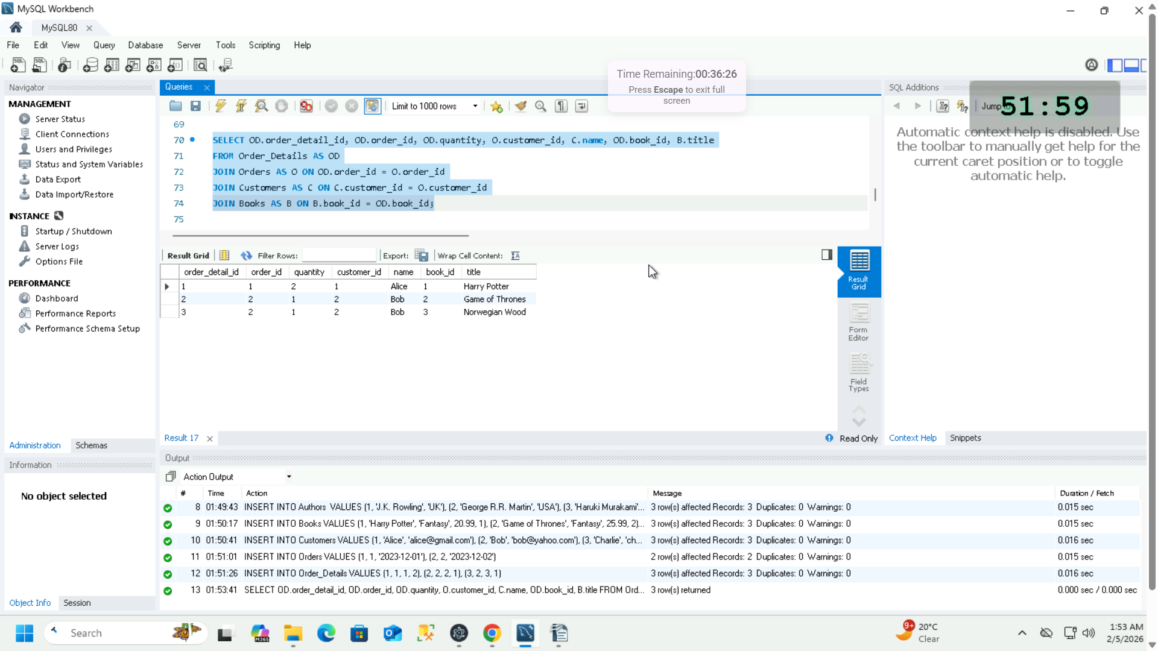

1. Joining Order_details, Books & Authors tables using their Foreign keys to display the list of authors and their total revenue generated from their books, which is book price multiplied by the quantity of books sold displayed under Total Revenue column  
   SELECT A.author_id, A.name, (OD.quantity * B.price) AS ‘Total Revenue’

FROM Order_Details AS OD

JOIN Books AS B ON B.book_id = OD.book_id

JOIN Authors AS A ON A.author_id = B.author_id;

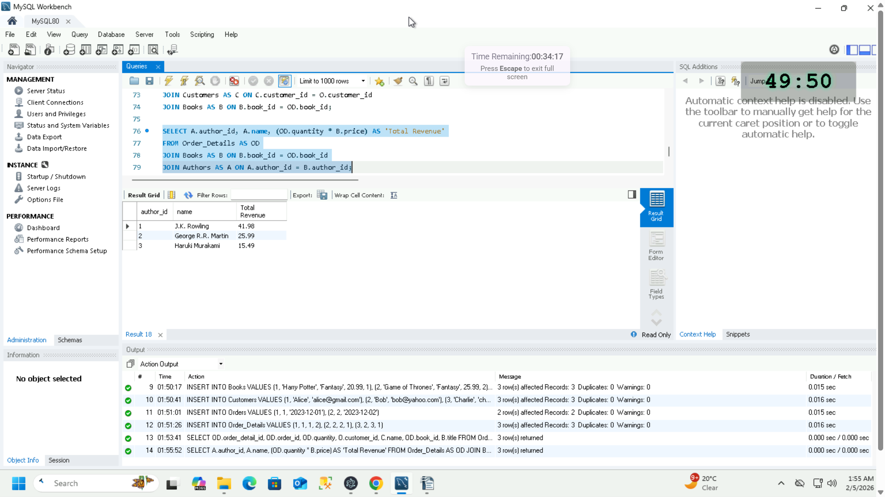

**Use Case 4:- (Sub Queries)**

1. Joining Books & Authors tables using foreign key and inside where condition there is a subquery which outputs the maximum price among all book prices. MAX is an aggregate function.  
   SELECT B.author_id, A.name, B.title, B.price

FROM Books AS B

JOIN Authors AS A ON A.author_id = B.author_id

WHERE B.price = (SELECT MAX(price) FROM Books);

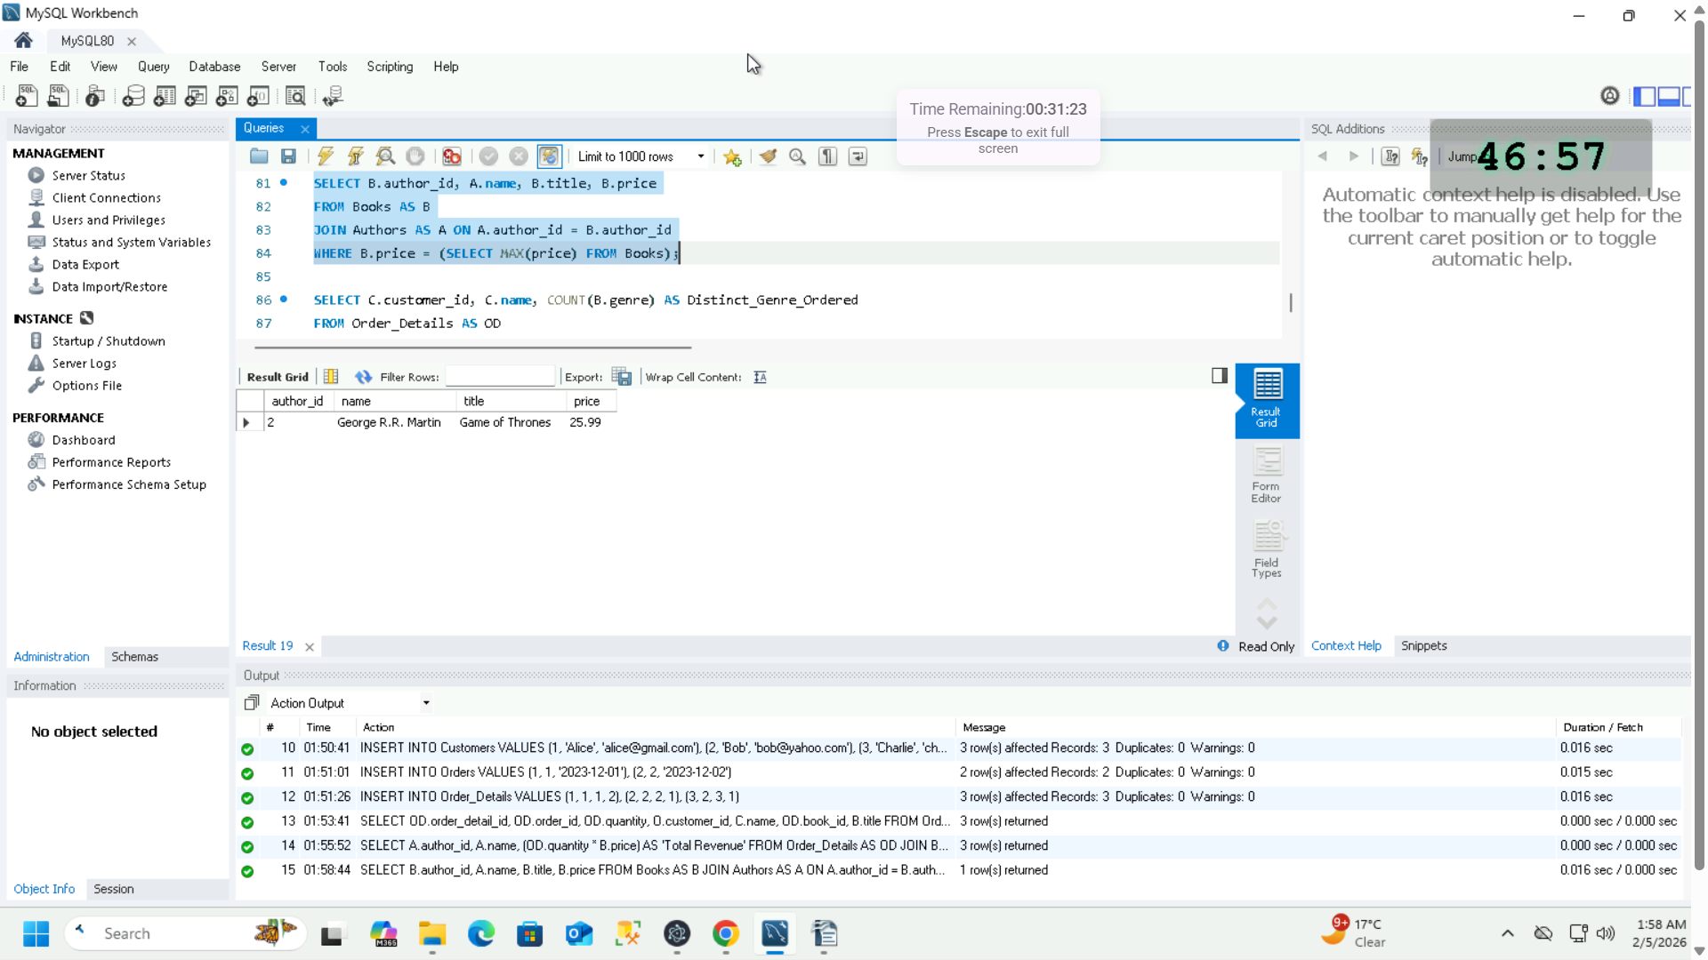

1. Joining Order_details, Books, Orders & Customers tables using their foreign keys to List customers who have ordered more than one type of book genre. This is done using the COUNT() aggregate function which operated on book genre and counts its occurrences. Next, the Group By clause groups similar Customer ids & names based on the condition that the occurrences of book genre for a specific customer Is more than 1  
     
   SELECT C.customer_id, C.name, COUNT(B.genre) AS Distinct_Genre_Ordered  
   FROM Order_Details AS OD  
   JOIN Orders AS O ON O.order_id = OD.order_id  
   JOIN Books AS B ON OD.book_id = B.book_id  
   JOIN Customers AS C ON C.customer_id = O.customer_id  
   GROUP BY C.customer_id, C.name  
   HAVING Distinct_Genre_Ordered > 1;

